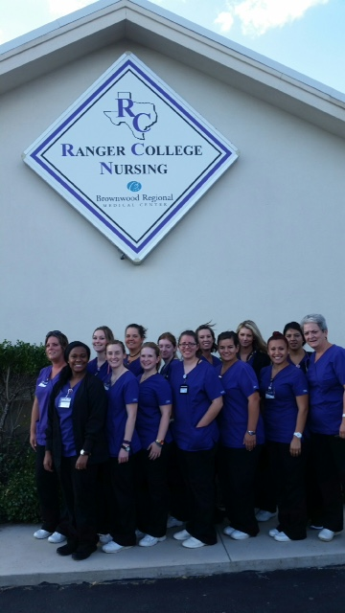  How do I get started in the Associate of Nursing Program?  ◦ Contact Carolyn Zapata  ◦ Apply to Ranger College  ◦ Schedule HESI entrance exam  ◦ Gather required documents:  ◦ Vaccination Record |  |  | The future of Nursing Belongs to Us!  Contact Us  Carolyn Zapata Dean of Nursing  Phone: 325-641-5726  Email: czapata@rangercollege.edu  Web: www.rangercollege.edu  Ranger College  1100 College Circle  Ranger, TX 76470 |  |  | Ranger College  Associate Degree  Nursing

Required Prerequisites:  ENG 1301 Composition I  BIOL 2401 A&P I  BIOL 2420 Microbiology  PYSC 2301 Intro. to Psychology  COSC 1401 Microcomputer Application  Additional Non-Nursing Courses:  BIOL 2401 A&P II  PSYC 2314 Life Span Growth & Development  * Humanities/Fine Arts Elective  ** Preferred humanities/fine arts electives:  ARTS 1301, DRAM 1310, HUMA 1315, MUSI 1306, PHIL 1301, ENGL 2000 or higher level of literature, or select foreign language of 4 credit hours |  |  | “Make me appreciative of the dignity of my high vocation and its many responsibilities. Never permit me to disgrace it by giving way to coldness, unkindness or impatience. Mother Teresa  Ranger College  Associate Degree Nursing  ◦ 4 Semester Program  ◦ Associate Degree Nursing  ◦ Eligible for NCLEX- RN Exam  ◦ Variety of Job Opportunities  ◦ RN Salary Range: $20 - 30/hour |  |  | Year 1  Semester I  RNSG1423 Intro. to Professional Nursing  BIOL 2402 Anatomy and Physiology II  PYSC 2314 Lifespan Grown & Development  RNSG 1119 Nursing Skills  RNSG1460 Clinical-Nursing  Semester II  RNSG 1129* Nursing Skills II  RNSG 2504* Integrated Care of the Client with Common Health Care Needs  RNSG 1311 Nursing Pathophysiology  RNSG 1461* Clinical-Nursing II  Year 2  Semester III  RNSG 2514* Care of Client with Complex Health Needs  RNSG 2560* Clinical-Nursing  Humanities/Fine Arts  Semester IV  RNSG 2535* Integrated Client Care Management  RNSG 2562* Clinical-Nursing III  RNSG2207* Transition to Nursing Practice

